QUESTION 1
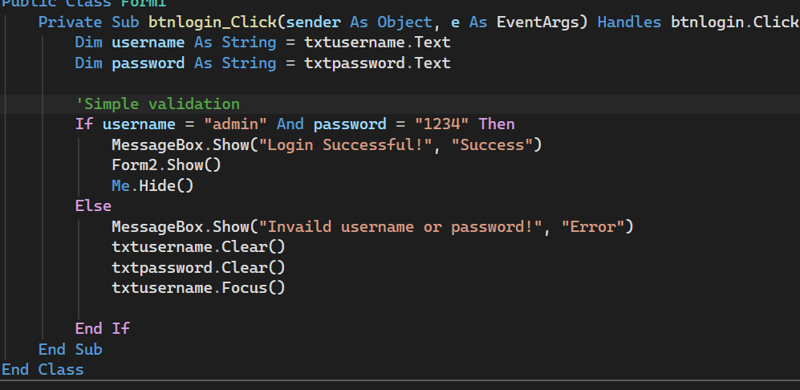

QUESTION 2: Shopping Mall Discount
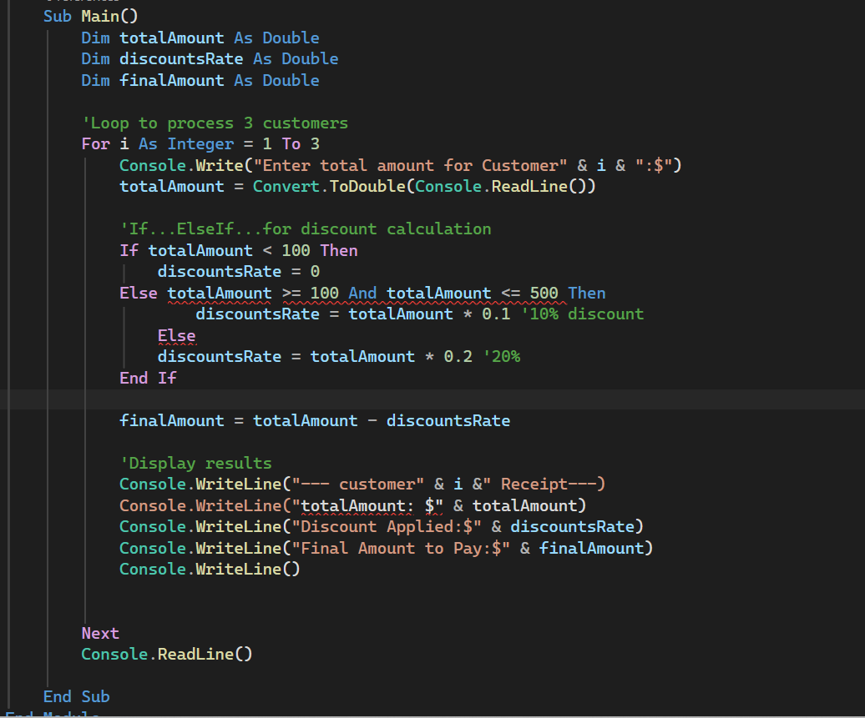
QUESTION 3: OOP in VB

a) Class and Object
A Class is a blueprint or template that defines properties (data) and methods (behavior) of an object. An Object is an instance of a class.
EXAMPLE

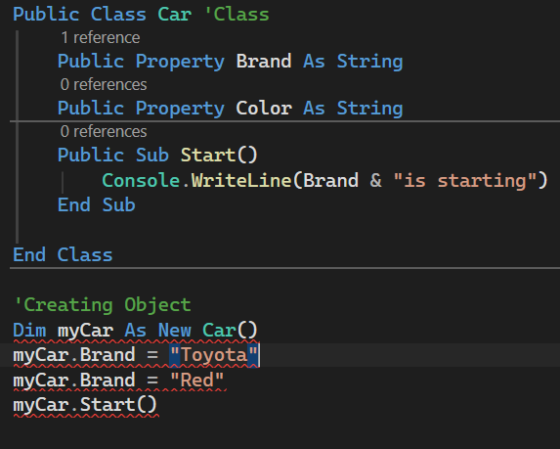

b) Inheritance vs Polymorphism
- Inheritance: A mechanism where a child class inherits properties and methods from a parent class. It promotes code reuse. E.g., Car inherits from Vehicle class.
- Polymorphism: Means "many forms" - same method name behaves differently in different classes. E.g., Parent class has Drawn () method, Child classes Circle and Square both override Draw () to draw differently.

c) Encapsulation
Encapsulation is bundling data and methods that operate on that data into a single unit (class) and hiding internal details from outside world using access modifiers (Public, Private, Protected).
Importance
1. Data security
2. Prevents unauthorized access
3. Easy maintenance
4. Controls how data is modified.

d) Constructors and Destructors Constructor (Sub New): A special method that runs automatically when an object is created. Used to initialize properties.
Destructor (Sub Finalize): Runs when object is destroyed. Used to clean up resources like closing files or database connections.
QUESTION 4: VB Concepts

a) Three Uses of Collections in VB
1. Storing multiple items: Store group of similar objects like list of student names without creating many variables. E.g., Array List, List.
2. Dynamic data management: Add, remove, search items easily at runtime. E.g., shopping cart items in a mall app.
3. Iterating and Sorting: Loop through items, sort, count. E.g., displaying all customers in a List Box.

b) Message Boxes and their Types
Message Box is used to display messages and get user response. Types:
-Message Box Style. Information: Shows info icon.
- Message Box Style. Exclamation / Warning: Shows warning icon.
-Message Box Style. Critical: Shows error icon.
- Message Box Style. Yes, No Cancel / Cancel: Shows buttons for user choice.
- Example: Message Box. Show ("Invalid marks!", "Error", Message Box Buttons. OK, Message Box Icon. Error)

c) Solution Explorer in Visual Studio
Solution Explorer is a window that shows the structure of your project. It helps in:
1. Managing files: View all forms, modules, classes.
2. Adding/removing items: Add new forms, references.
3. Organizing project: Create folders, rename files.
4. Quick navigation: Double-click to open code.

QUESTION 5: Student Grade Management System
Part A: Input and Validation 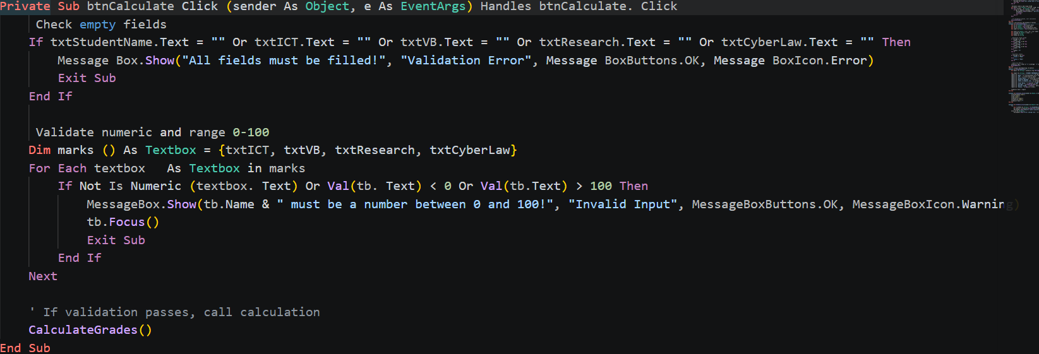

Part B: Calculations and Grading (8 marks)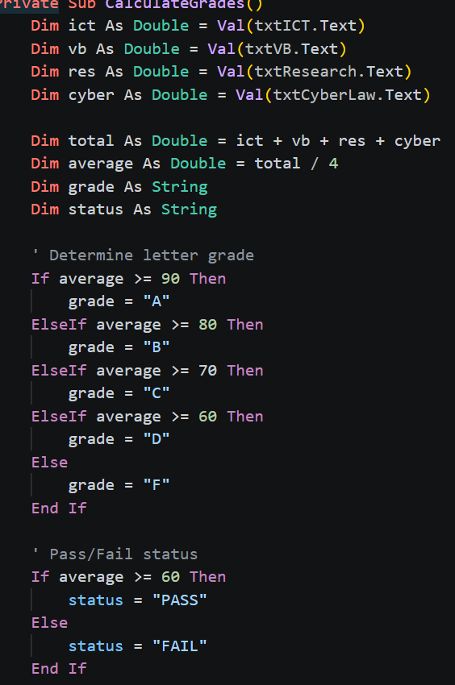

Part C: Output and Reporting
